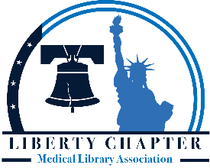

Beatrice Davis Education Award Application Form
Last Name |  | First Name
Current Address |  | Permanent Address (optional)
E-mail | Daytime Phone |  | Evening Phone |  | Best Time to Call A.M. P.M.
Library School | Graduate Program |  |  | Advisor
Employer’s Name |  | Employer’s Address
Please mark the documentation which accompanies this application:
- Letter of Application
- Letter of recommendation
- Proof of Enrollment in an ALA- Accredited Program
- Resume
Deadline: September 30, 2023
Return application form and accompanying documentation to: chair@libertymla.org

I understand the conditions of the grant and will submit proof that the terms of the grant have been met upon the completion of the program. If I am unable to fulfill the terms of the grant, I will refund all monies received.
Signature of Applicant |  | Date

